# **Problem #11 to #15 Solutions**

==================================================

# **Problem 11**

=====================

Description: Write A program to: Average Pass/Fail

=========================================

#include <iostream>

using n amespace std;

enum enPassFail {Pass = 1 , Fail = 2};

void ReadNumbers(int& Mark1,int& Mark2,int& Mark3){

cout<<"\nEnter Mark 1: ";

cin>> Mark1;

cout<<"\nEnter Mark 2: ";

cin>> Mark2;

cout<<"\nEnter Mark 3: ";

cin>> Mark3;

}

int SumOf3Numbers(int Mark1,int Mark2, int Mark3){

return Mark1 + Mark2 + Mark3;

}

float CalculateAverage(int Mark1,int Mark2, int Mark3){

return (float)SumOf3Numbers(Mark1 , Mark2, Mark3) / 3;

}

enPassFail CheckAverage(float Averag){

if(Averag >= 50)

return enPassFail::Pass;

else

return enPassFail::Fail;

}

void PrinResults(float Average){

cout<<"\nThe Average Is: "<<Average<<endl;

if(CheckAverage(Average) == enPassFail::Pass)

cout<<"\nYou Passed"<<endl;

else

cout<<"\nYou Failed"<<endl;

}

int main(){

int Mark1,Mark2,Mark3;

ReadNumbers(Mark1,Mark2,Mark3);

PrinResults(CalculateAverage(Mark1,Mark2,Mark3));

return 0;

}

========================================================================

The Output:

============

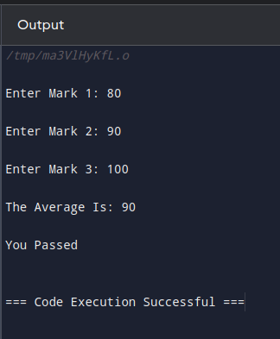

========================================================================

# **Problem 12**

=========================

Description:Write A Program To get the max of two Numbers;

================================================

#include <iostream>

using namespace std;

void ReadNumbers(int& N1,int& N2){

cout<<"\nEnter Number 1: ";

cin>> N1;

cout<<"\nEnter Number 2: ";

cin>>N2;

}

int MaxOf2Numbers(int N1, int N2){

if(N1 > N2)

return N1;

else

return N2;

}

void PrintResults(int Max){

cout<<"\nThe Max Number Is: "<<Max<<endl;

}

int main(){

int N1,N2;

ReadNumbers(N1, N2);

PrintResults(MaxOf2Numbers(N1,N2));

return 0;

}

========================================================================

The Output:

============

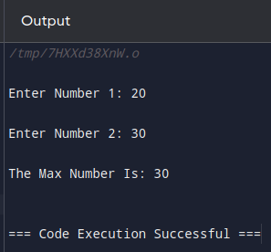

========================================================================

# **Problem 13**

=======================

Description:Write A Program To get the max of threeNumbers;

=======================================================

#include <iostream>

using namespace std;

void ReadNumbers(int& N1,int& N2, int& N3){

cout<<"\nEnter Number 1: ";

cin>> N1;

cout<<"\nEnter Number 2: ";

cin>>N2;

cout<<"\nEnter Number 3: ";

cin>> N3;

}

int MaxOf3Numbers(int N1, int N2, int N3){

if(N1 > N2 && N1 > N3){

return N1;

}else if(N2 > N1 && N2 > N3){

return N2;

}else{

return N3;

}

}

void PrintResults(int Max){

cout<<"\nThe Max Number Is: "<<Max<<endl;

}

int main(){

int N1,N2,N3;

ReadNumbers(N1, N2,N3);

PrintResults(MaxOf3Numbers(N1,N2,N3));

return 0;

}

========================================================================

The Output

==========

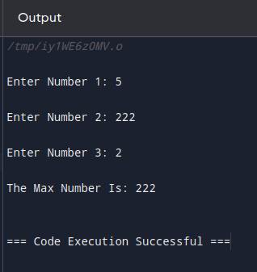

========================================================================

# **Problem 14**

========================

Description: Write A program To Swap Two Numbers:

==========================================

#include <iostream>

using namespace std;

void ReadNumbers(int& N1,int& N2){

cout<<"\nEnter Number 1: ";

cin>> N1;

cout<<"\nEnter Number 2: ";

cin>>N2;

}

void Swap(int& N1, int& N2){

int temp = 0;

temp = N1;

N1 = N2;

N2 = temp;

}

void PrintResults(int N1, int N2){

cout<<"Number 1: "<<N1<<endl;

cout<<"Number 2: "<<N2<<endl;

}

int main(){

int N1, N2;

ReadNumbers(N1,N2);

PrintResults(N1,N2);

Swap(N1,N2);

PrintResults(N1,N2);

return 0;

}

========================================================================

Output:

=========================

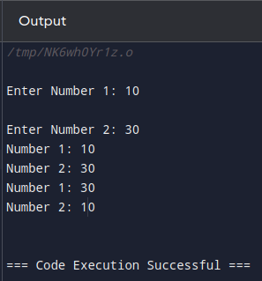

========================================================================

# **Problem 15**

=========================

Description: Write a Program Rectangle Area

=================================

#include <iostream>

using namespace std;

void ReadNumbers(float& A , float& B){

cout<<"\nEnter A: ";

cin>> A;

cout<<"\nEnter B: ";

cin>>B;

}

float CalculateRectangleArea(float A, float B){

return A * B;

}

void PrintResult(float Area){

cout<<"The Area Is: "<<Area<<endl;

}

int main(){

float A, B;

ReadNumbers(A, B);

PrintResult(CalculateRectangleArea(A,B));

return 0;

}

========================================================================

The Output:

=============

